- NNA
Responsibility: NNA – PO PURCHASING SUPER USER
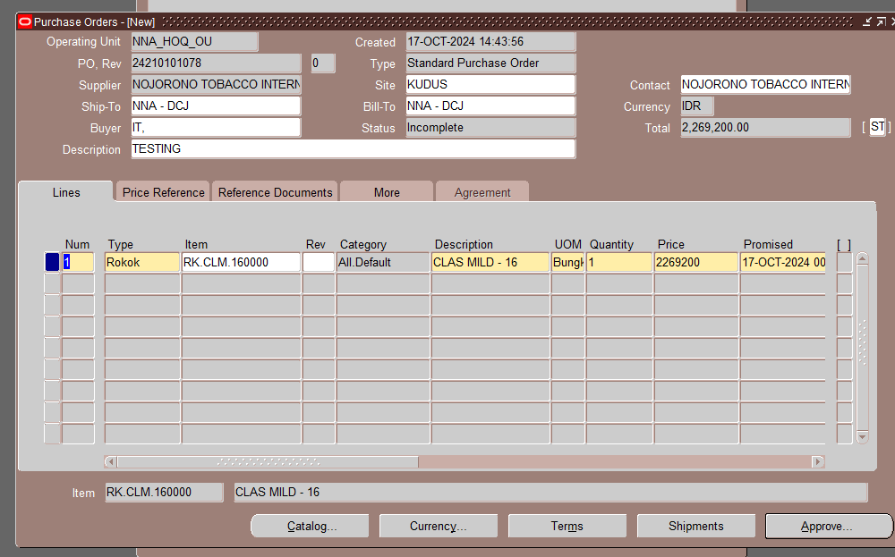
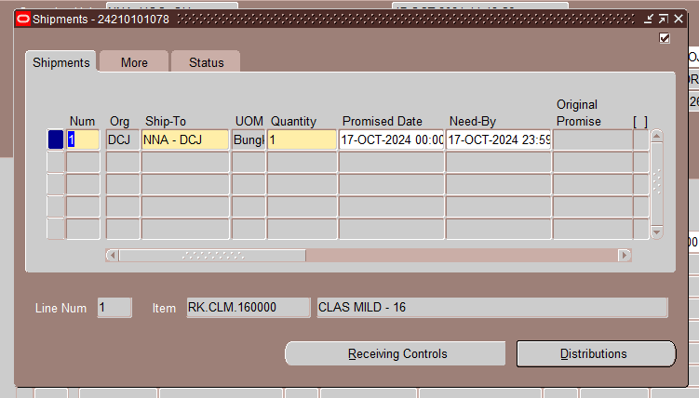
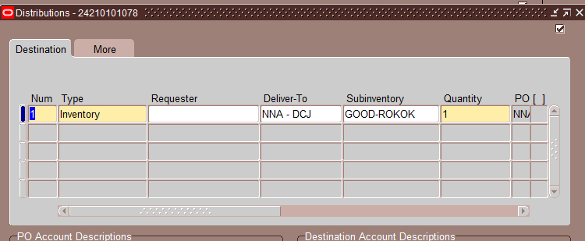

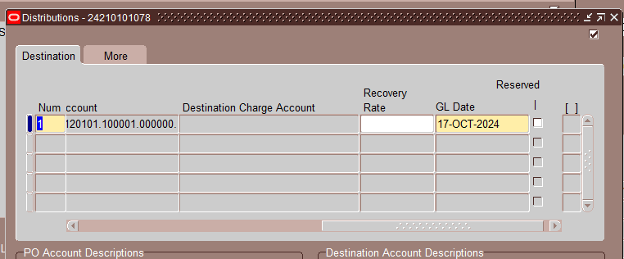

Lakukan approve
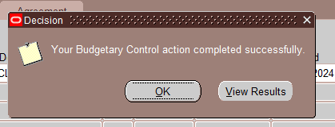

Cek dengan query berikut:

select asp.vendor_id
, asp.vendor_name dist_vendor_name
, pha.segment1 dist_po_number
, pha.po_header_id dist_po_header_id
, pha.comments
, to_char(pha.creation_date, 'DD-MM-RRRR HH24:MI:SS') dist_po_creation_date
, to_char(pha.approved_date, 'DD-MM-RRRR HH24:MI:SS') dist_po_approved_date
, asp.attribute15 customer_id
from po_headers_all pha
, ap_suppliers asp
where 1=1
-- and asp.vendor_id = p_vendor_id
and pha.vendor_id = asp.vendor_id
and asp.attribute6 like 'PRINC%'
and asp.attribute15 is not null
and pha.approved_date is not null
/*Disabled for testing*/
and pha.approved_date between sysdate-4/24 and sysdate
and not exists (select '1' from XTD_PO_PRINCIPAL_TXTFILE_STG where dist_po_header_id = pha.po_header_id)
-- and asp.vendor_name in ('NOJORONO TOBACCO INTERNATIONAL, PT', 'NIKKI SUPER TOBACCO INDONESIA, PT', 'NIKORAMA CITRA TOBACCO, PT', 'AROMA TOBACCO INTERNATIONAL, PT')
order by approved_date desc

hasil:
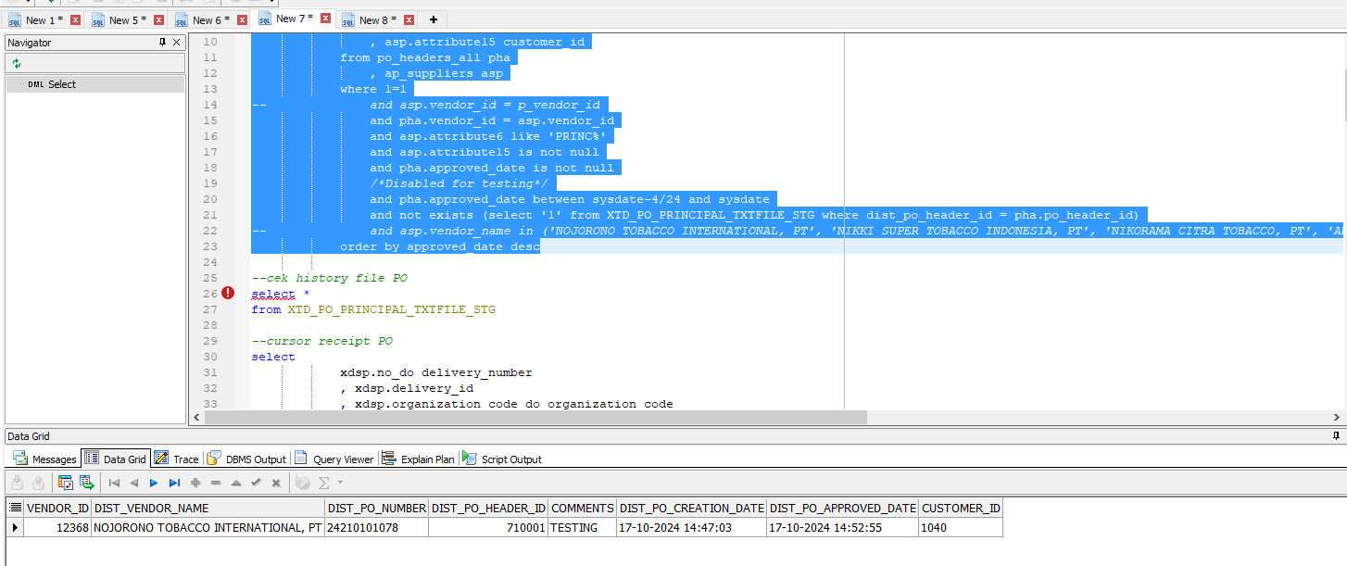

Pembentukan file PO dari API berikut:
begin
XTD_FND_INT_TXTFILE_PKG.write_po_txtfile;
end;

Hasil:

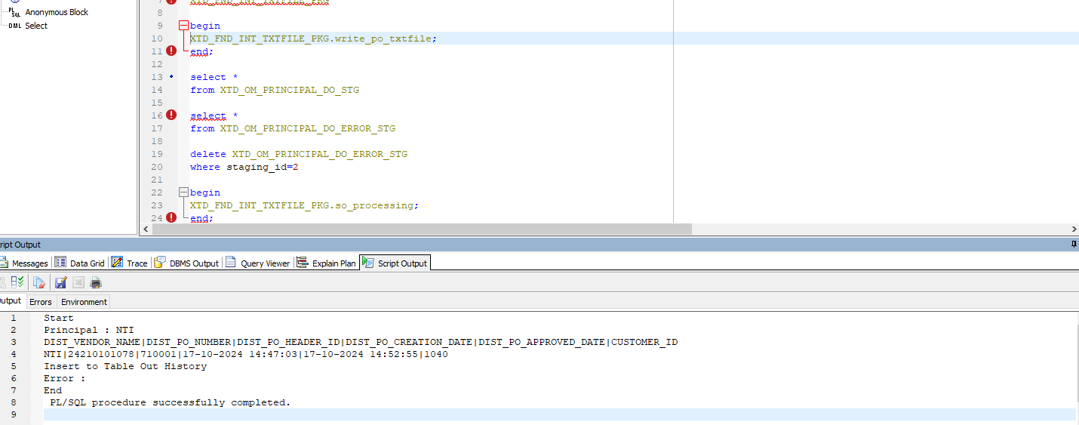

Hasil di ftp terbentuk:
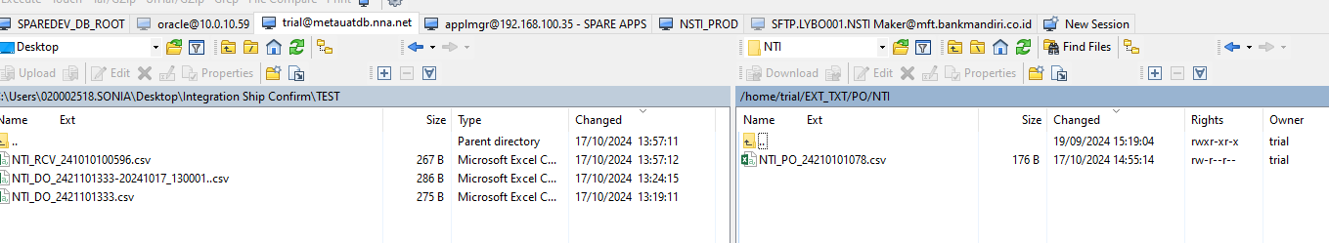
Cek historical file yang terbentuk:
select *
from XTD_PO_PRINCIPAL_TXTFILE_STG

- NTI
File terkirim ke NTI, dan bisa dilihat pada query berikut:
select *
from XTD_OM_PO_NUM_STG
order by creation_date desc

Buat SO
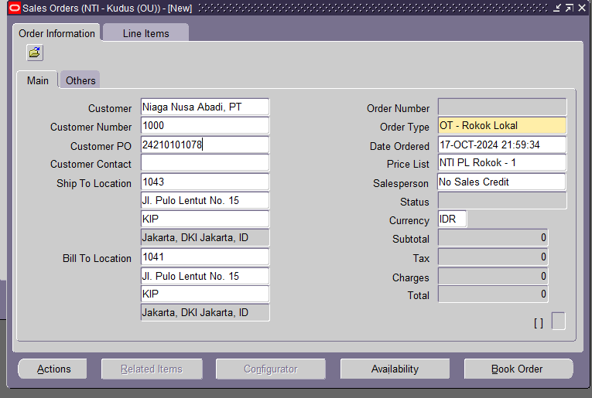
Contoh no po NNA: 24210101078
Item: RK.MN.CMS16HD24
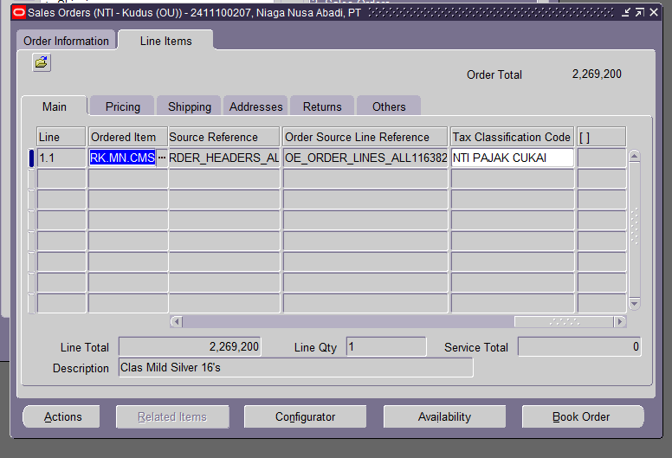
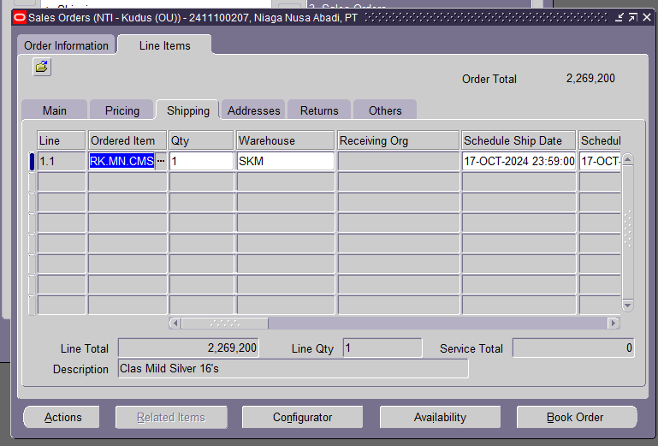
Klik book
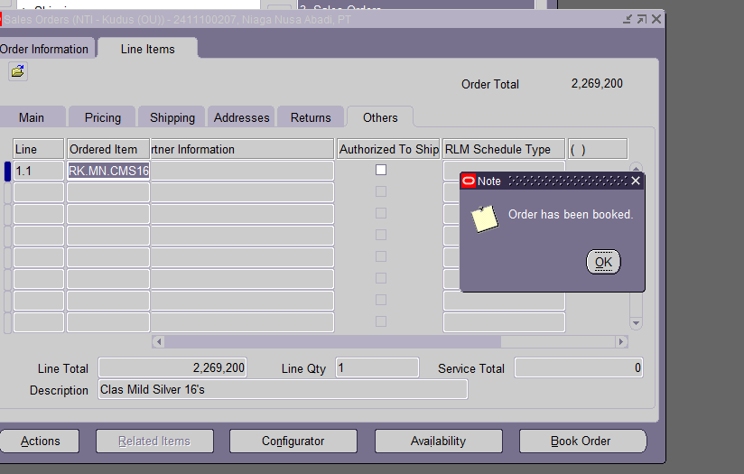
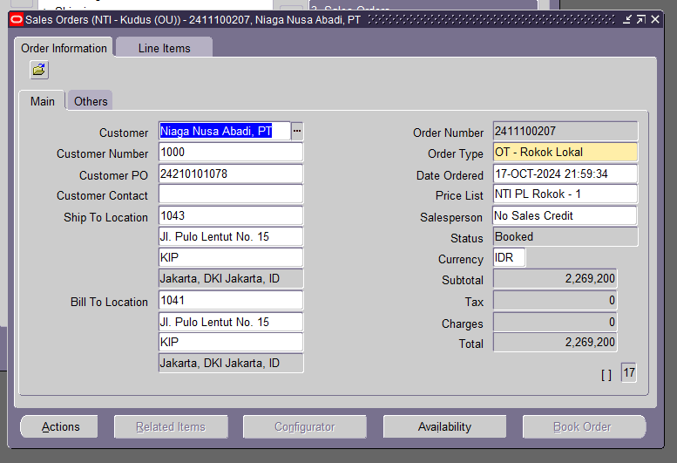Status = Booked

Lakukan pick release
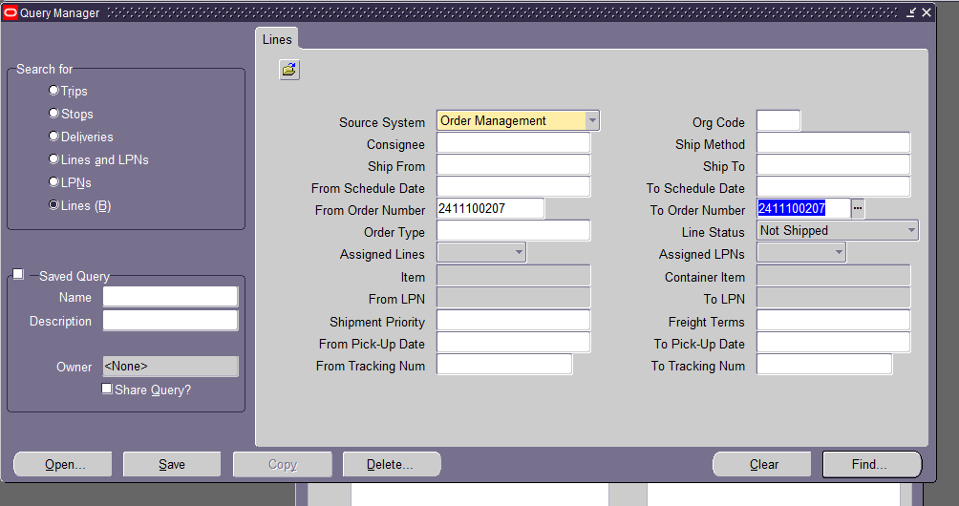
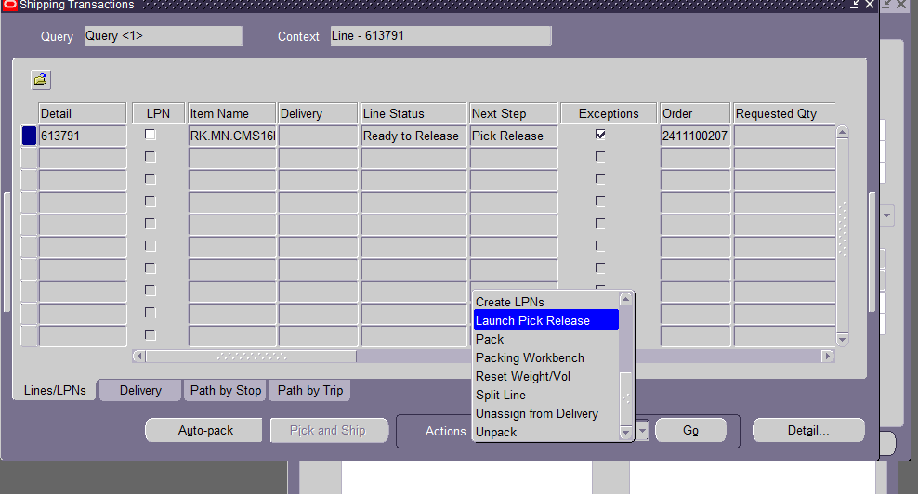
Pilih Launch Pick Release > Klik Go

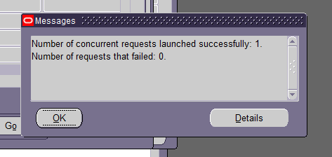

Create Delivery
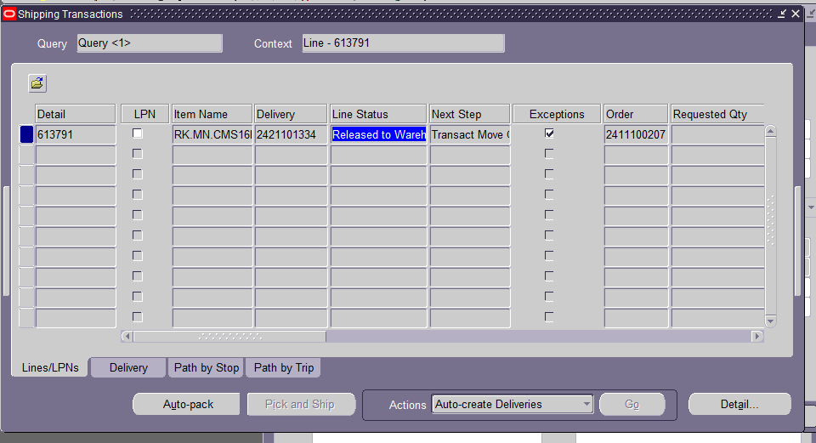
No Delivery ID: 613791
No Move Order: 1046523
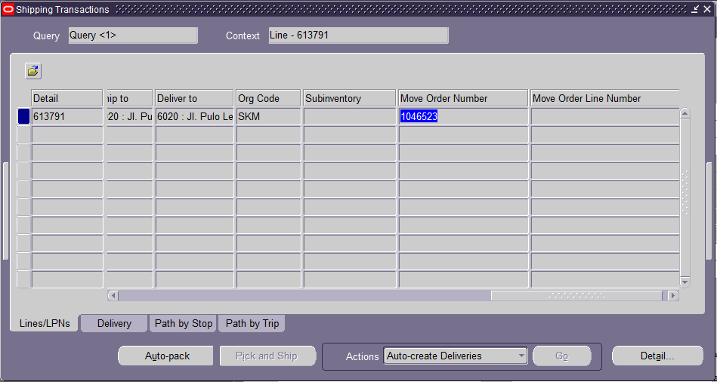
Lakukan Transact Move Order

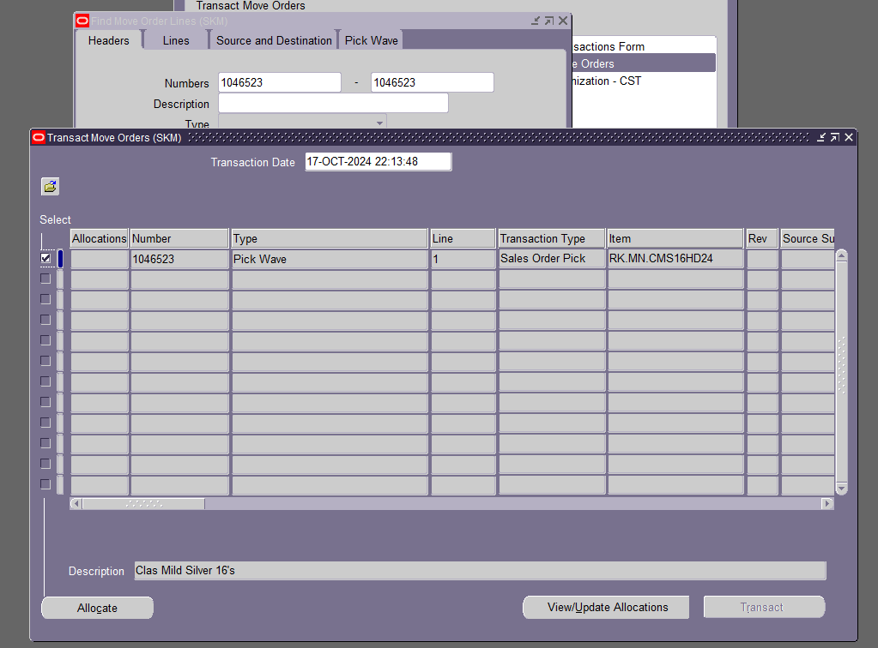
Klik Allocate
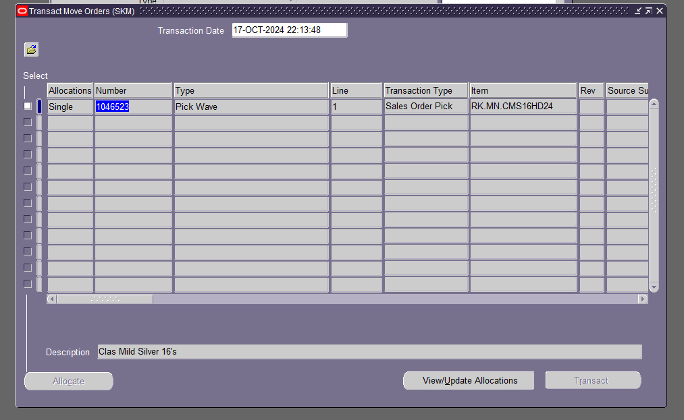
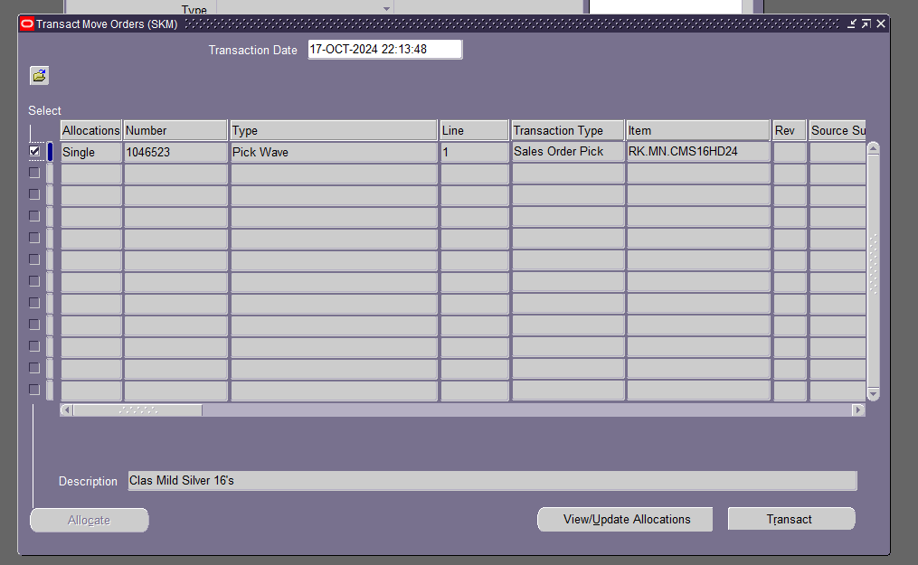
Klik Transact

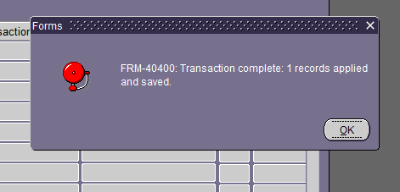

Update informasi di Shipping Transaction
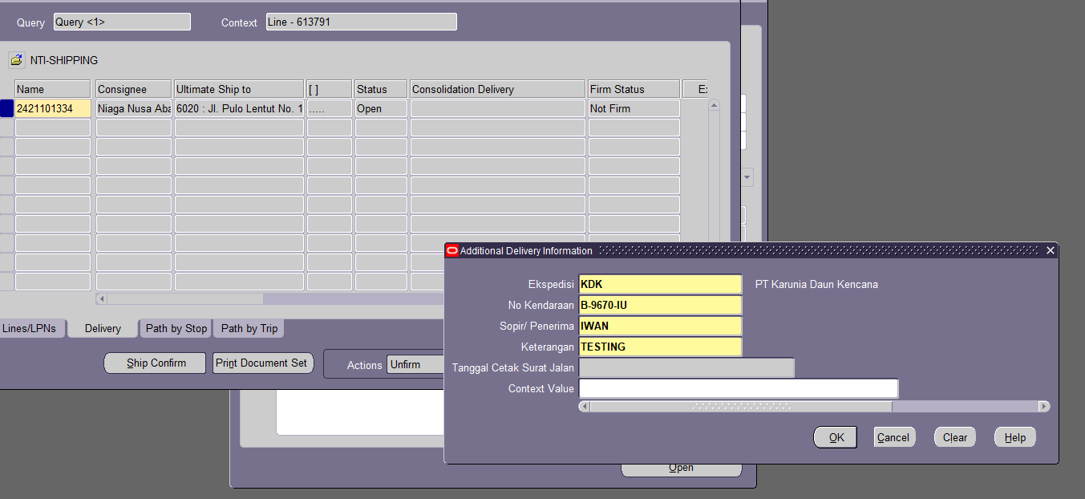

Cetak picking slip
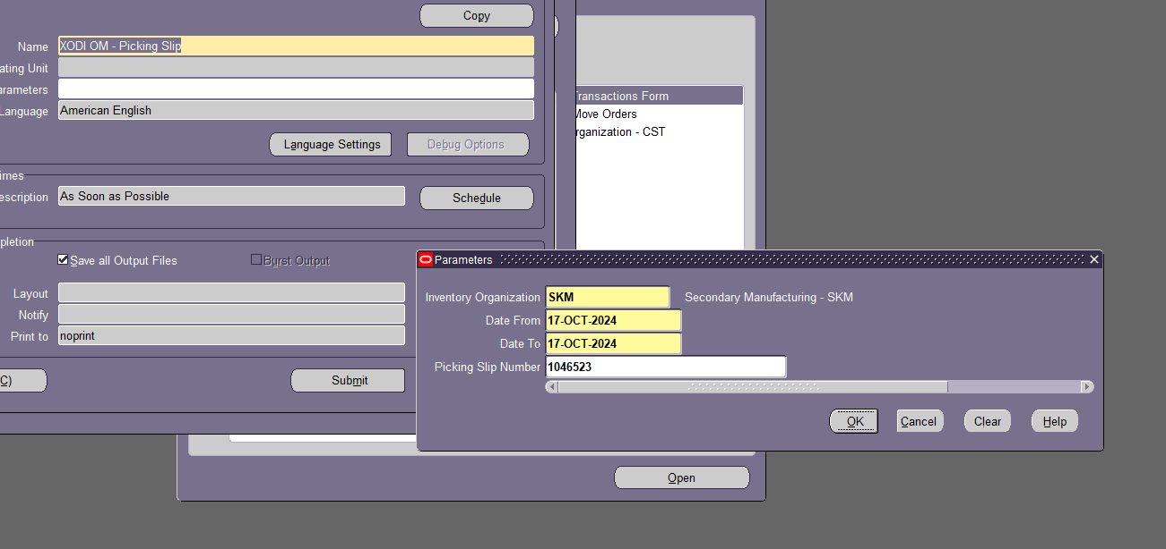
Contoh:
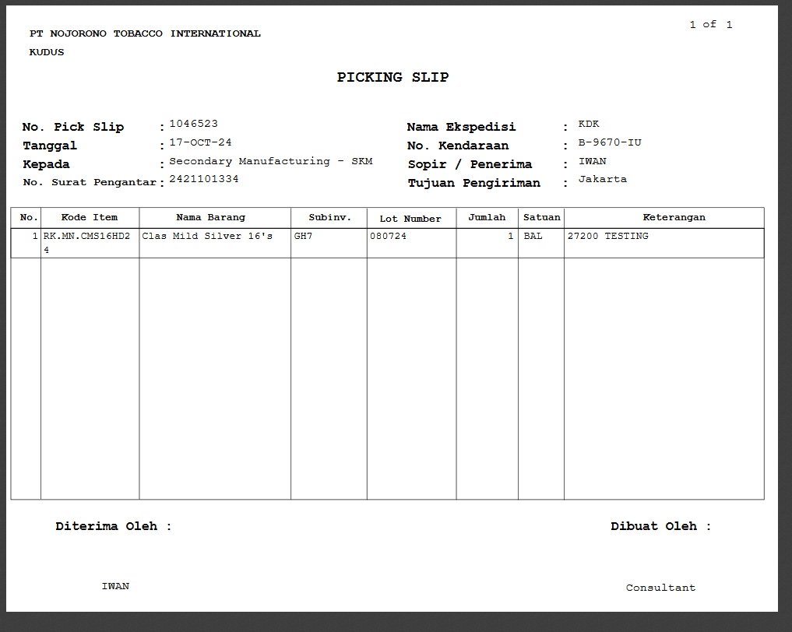
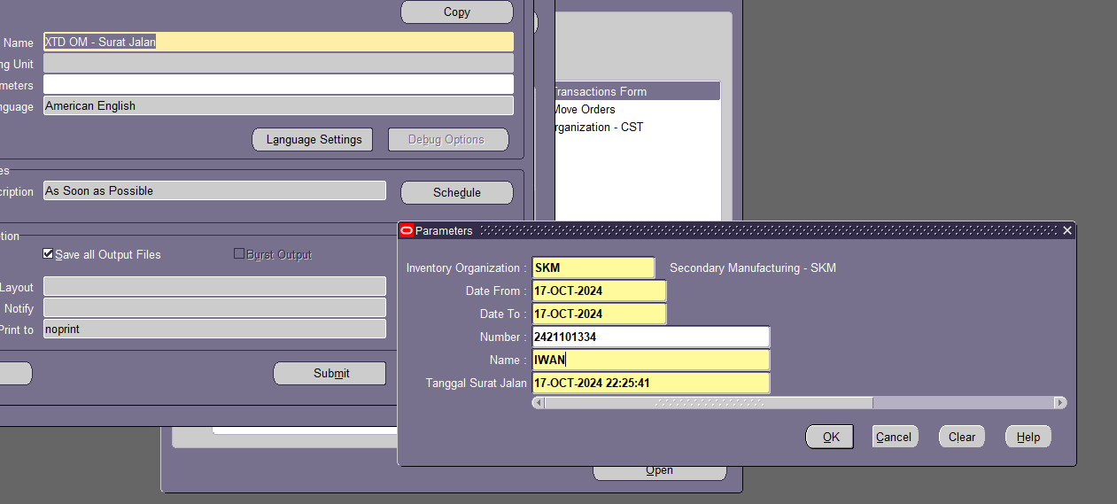
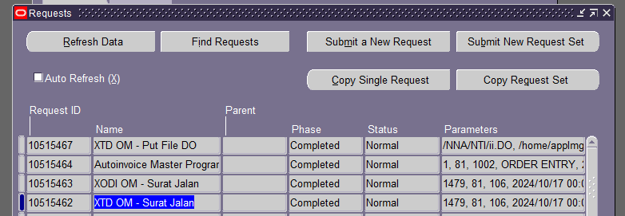
File DO juga akan terbentuk di sftp NTI dan di file server SFTP 10.0.29.31
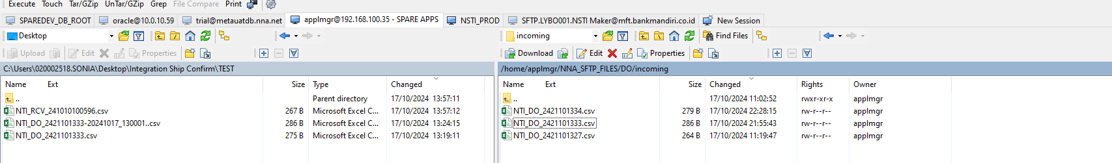
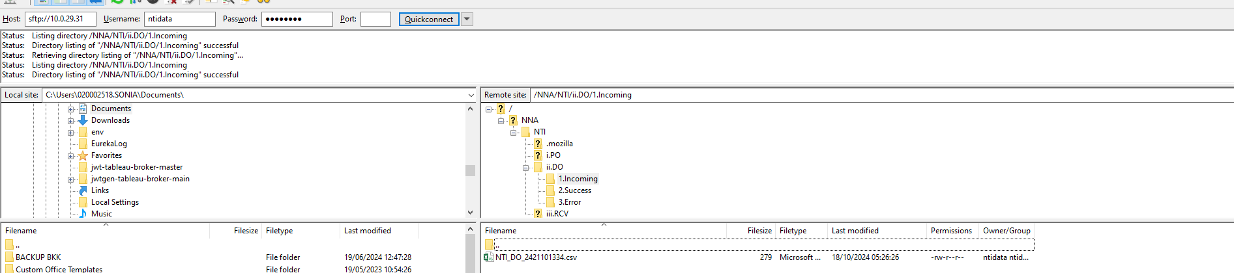
Email terkirim
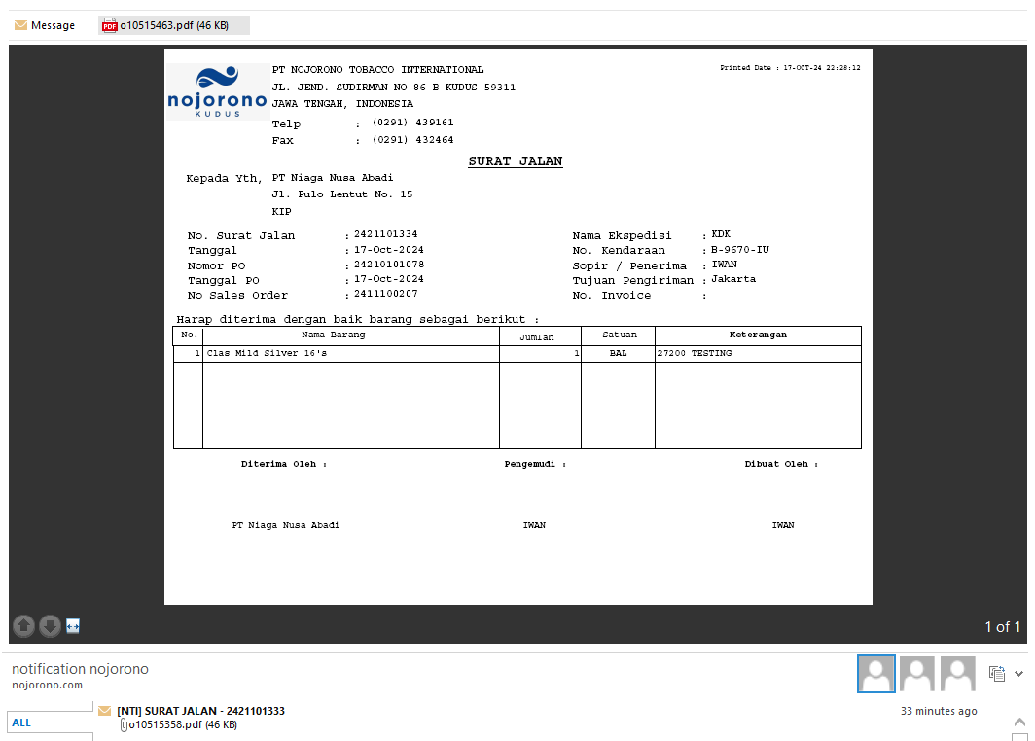

- NNA
Data terkirim ke SFTP Oracle NNA
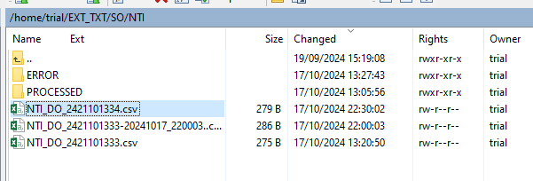

Query cursor

select * from (
SELECT 'NTI' company, substr(column_value, 1, length(column_value)-4) filename, substr(column_value, -3, 3) ext, column_value
FROM TABLE (list_files ('/home/trial/EXT_TXT/SO/NTI'))
where 1=1
and column_value like '%.csv'
union all
SELECT 'NSTI' company, substr(column_value, 1, length(column_value)-4) filename, substr(column_value, -3, 3) ext, column_value
FROM TABLE (list_files ('/home/trial/EXT_TXT/SO/NSTI'))
where 1=1
and column_value like '%.csv'
union all
SELECT 'NCT' company, substr(column_value, 1, length(column_value)-4) filename, substr(column_value, -3, 3) ext, column_value
FROM TABLE (list_files ('/home/trial/EXT_TXT/SO/NCT'))
where 1=1
and column_value like '%.csv'
union all
SELECT 'ATI' company, substr(column_value, 1, length(column_value)-4) filename, substr(column_value, -3, 3) ext, column_value
FROM TABLE (list_files ('/home/trial/EXT_TXT/SO/ATI'))
where 1=1
and column_value like '%.csv'
) tbl
where 1=1
-- and not exists (select * from XTD_AP_IBANK_INBOUND_HEADERS where file_name = tbl.filename)
and rownum < 2
order by tbl.column_value

Proses masuk ke table:
begin
XTD_FND_INT_TXTFILE_PKG.so_processing;
end;

Run F5
Result
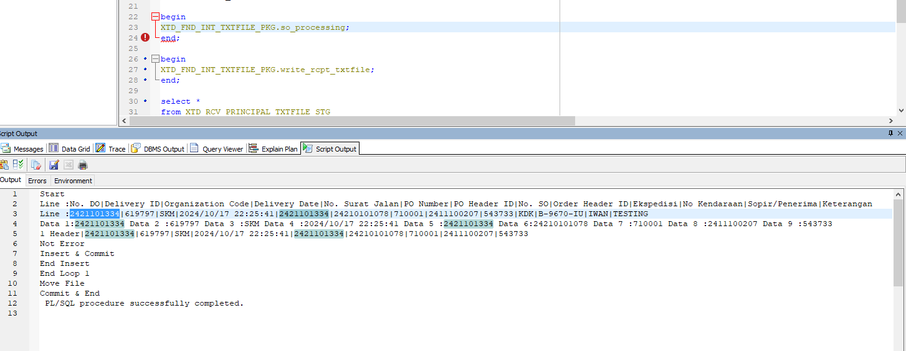

Data yang sudah diproses akan masuk ke folder PROCESSED di SFTP Oracle NNA
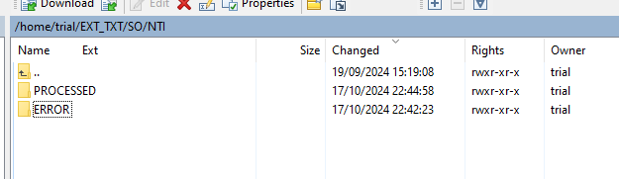

Untuk data staging
select *
from XTD_OM_PRINCIPAL_DO_STG
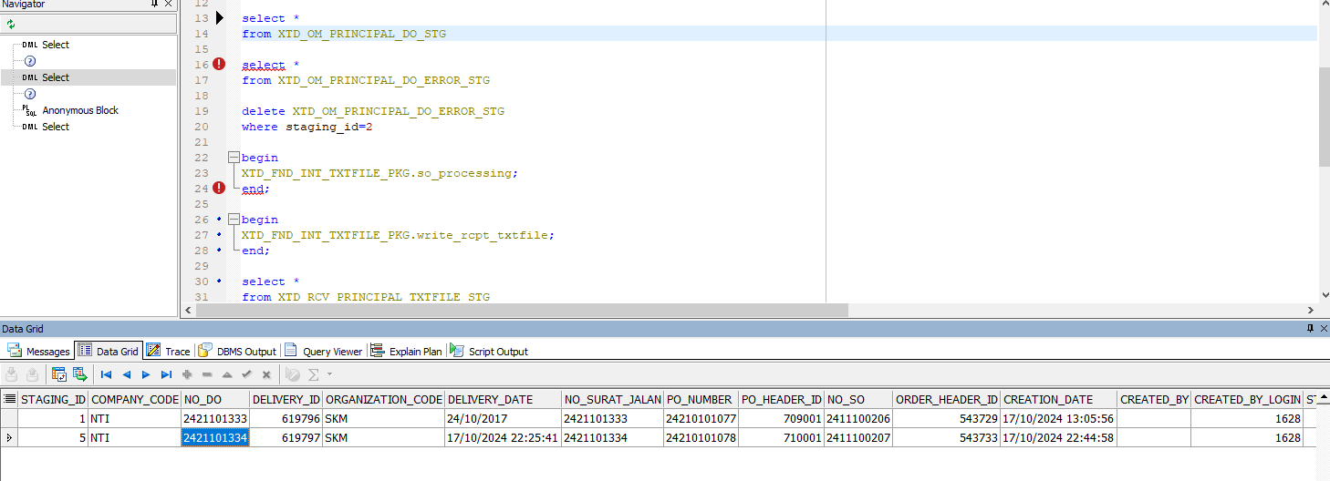

Receipt PO
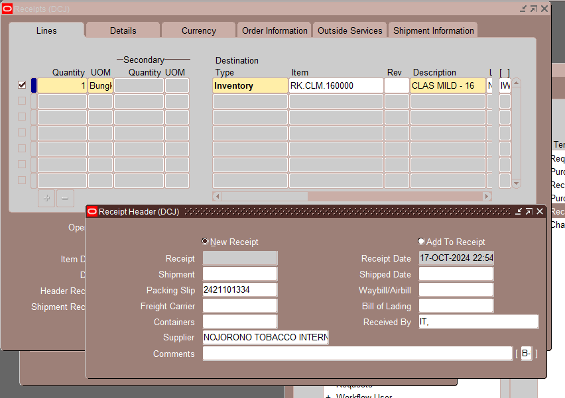
Nomor Receipt: 241010100597

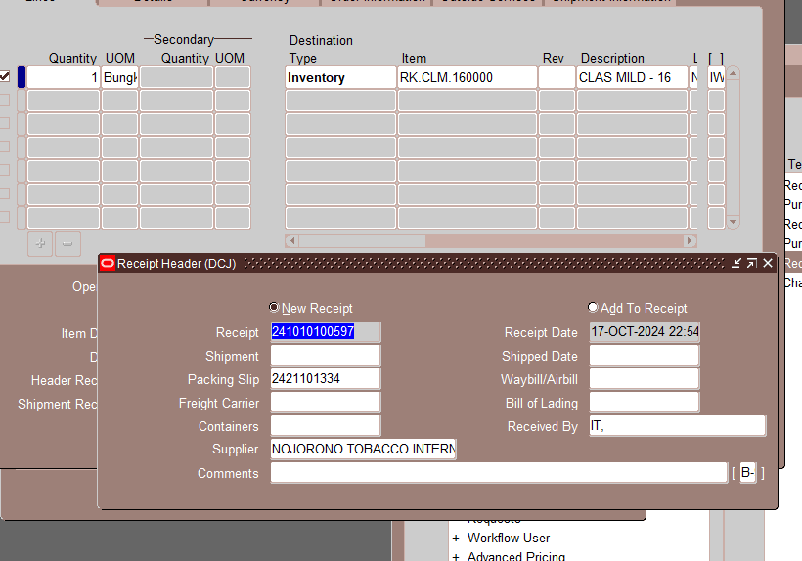

Cursor untuk pembentukan file nya:

select
xdsp.no_do delivery_number
, xdsp.delivery_id
, xdsp.organization_code do_organization_code
, rt.transaction_date dist_receipt_date
, rsh.receipt_num dist_no_receipt
, (select segment1 from po_headers_all where po_header_id = rt.po_header_id) dist_po_number
, rt.po_header_id dist_po_header_id
, rt.transaction_id dist_rcv_transaction_id
, xdsp.no_so sales_order_number
, xdsp.order_header_id
, null status
, null creation_date
, null last_update_date
, asp.vendor_name
-- , xdsp.*
from rcv_shipment_headers rsh
, rcv_transactions rt
, (select asp.vendor_id
, asp.vendor_name
from ap_suppliers asp
where 1=1
and asp.attribute6 like 'PRINC%'
and asp.attribute15 is not null) asp
-- , xtd.xtd_do_so_principal xdsp
, XTD_OM_PRINCIPAL_DO_STG xdsp
where 1=1
-- and rt.vendor_id = p_vendor_id
and rsh.shipment_header_id = rt.shipment_header_id
and rt.transaction_type = 'DELIVER'
and rt.vendor_id = asp.vendor_id
and rt.po_header_id = xdsp.po_header_id
and rt.transaction_date between sysdate-4/24 and sysdate
and not exists (select '1' from XTD_RCV_PRINCIPAL_TXTFILE_STG where dist_rcv_transaction_id = rt.transaction_id)

Jalankan API berikut:
begin
XTD_FND_INT_TXTFILE_PKG.write_rcpt_txtfile;
end;

Result:
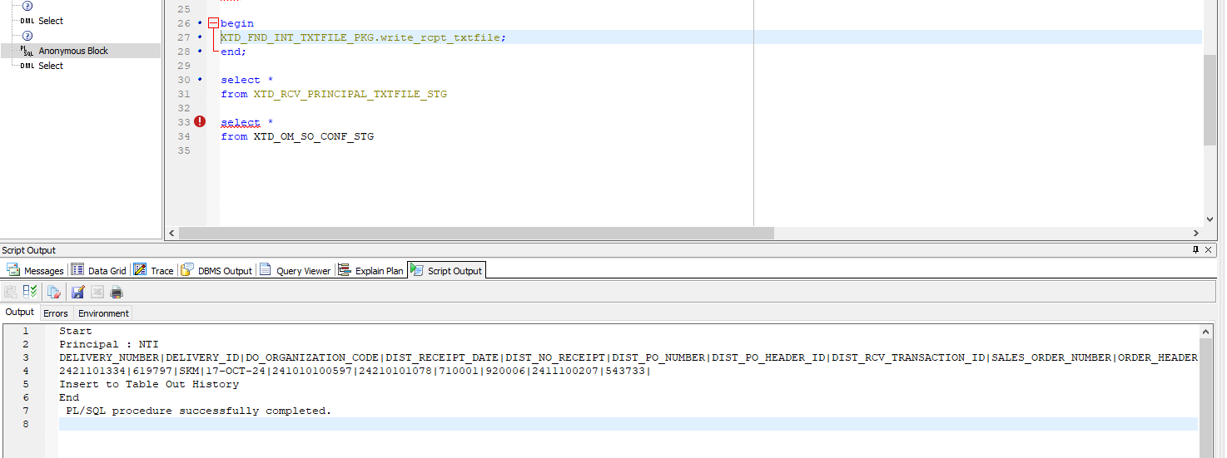

- NTI
Jalankan concurrent XTD OM – Get File SO
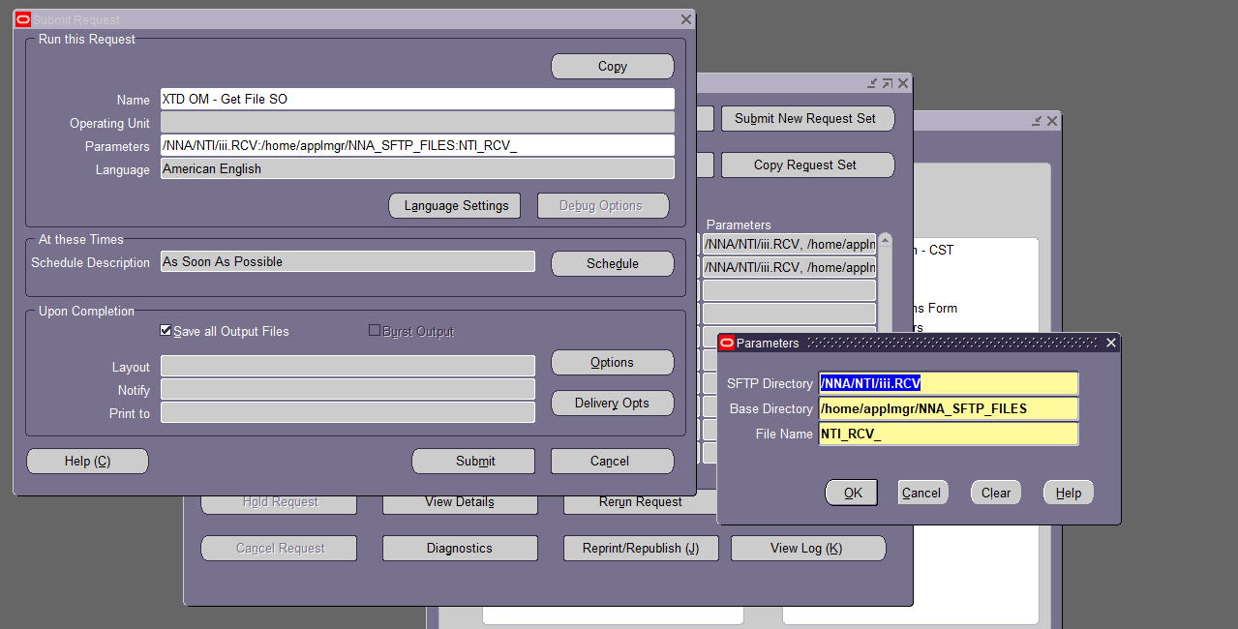

Contoh hasil log:
+---------------------------------------------------------------------------+
Extended Application: Version : 12.2

Copyright (c) 1998, 2013, Oracle and/or its affiliates. All rights reserved.

XTD_OM_GET_FILE_SO: XTD OM - Get File SO
+---------------------------------------------------------------------------+

Current system time is 18-OCT-2024 08:48:26

+---------------------------------------------------------------------------+

/u02/Apps/Dev/fs1/EBSapps/appl/xtd/12.0.0/bin/XTD_OM_GET_FILE_SO.prog\nCONCURRENT PROGRAM PARAMETER:
Login = APPS/apps
User ID = 1479
Username = NTI
Request ID = 10517353
Parameter 1 = /NNA/NTI/iii.RCV
Parameter 2 = /home/applmgr/NNA_SFTP_FILES
Parameter 3 = NTI_RCV_
Parameter 4 = 10.0.29.31
Parameter 5 = ntidata
Parameter 6 = nti2024#
Parameter 7 = 1.Incoming
Parameter 8 = 2.Success
Parameter 9 = 3.Error
v_directory = /home/applmgr/NNA_SFTP_FILES/RCV
+---------------------------------------------------------------------------+
Connected.
"ONT" "OM Superuser"
v_apps_initialize "ONT" "OM Superuser"
==================
Program Initiated
ftp log :
spawn sftp ntidata@10.0.29.31
ntidata@10.0.29.31's password:
Connected to 10.0.29.31.
sftp> cd /NNA/NTI/iii.RCV/1.Incoming
sftp> get NTI_RCV_*.csv /home/applmgr/NNA_SFTP_FILES/RCV
Fetching /NNA/NTI/iii.RCV/1.Incoming/NTI_RCV_241010100597.csv to /home/applmgr/NNA_SFTP_FILES/RCV/NTI_RCV_241010100597.csv

/NNA/NTI/iii.RCV/1.Incoming/NTI_RCV_241010100 0% 0 0.0KB/s --:-- ETA
/NNA/NTI/iii.RCV/1.Incoming/NTI_RCV_241010100 100% 267 0.3KB/s 00:00
sftp> : 0 - 0
==================
Processing NTI_RCV_241010100597.csv
Successfully Loaded All Records to XTD_OM_SO_CONF_STG

SQL*Loader: Release 10.1.0.5.0 - Production on Fri Oct 18 08:48:26 2024

Copyright (c) 1982, 2005, Oracle. All rights reserved.

Control File: 10517353.ctl
Data File: /home/applmgr/NNA_SFTP_FILES/RCV/NTI_RCV_241010100597.csv.tmp
Bad File: /home/applmgr/NNA_SFTP_FILES/RCV/log/NTI_RCV_241010100597.csv.bad
Discard File: none specified

(Allow all discards)

Number to load: ALL
Number to skip: 1
Errors allowed: 999999
Bind array: 64 rows, maximum of 256000 bytes
Continuation: none specified
Path used: Conventional
Silent options: FEEDBACK
Table XTD_OM_SO_CONF_STG, loaded from every logical record.
Insert option in effect for this table: APPEND
TRAILING NULLCOLS option in effect

Column Name Position Len Term Encl Datatype
------------------------------ ---------- ----- ---- ---- ---------------------
DELIVERY_ORDER_NO FIRST * | O(") CHARACTER
DELIVERY_ORDER_ID NEXT * | O(") CHARACTER
IO_CODE NEXT * | O(") CHARACTER
RECEIPT_DATE NEXT * | O(") DATE DD-MM-RRRR HH24:MI:SS
RECEIPT_NUMBER_NNA NEXT * | O(") CHARACTER
PO_NUMBER NEXT * | O(") CHARACTER
PO_HEADER_ID NEXT * | O(") CHARACTER
RCV_TRANSACTION_ID NEXT * | O(") CHARACTER
SALES_ORDER_NO NEXT * | O(") CHARACTER
ORDER_HEADER_ID NEXT * | O(") CHARACTER
FILENAME CONSTANT
Value is 'NTI_RCV_241010100597.csv'
REQUEST_ID CONSTANT
Value is '10517353'
CREATED_BY NEXT * | O(") CHARACTER
SQL string for column : "1479"
LAST_UPDATED_BY NEXT * | O(") CHARACTER
SQL string for column : "1479"

Table XTD_OM_SO_CONF_STG:
1 Row successfully loaded.
0 Rows not loaded due to data errors.
0 Rows not loaded because all WHEN clauses were failed.
0 Rows not loaded because all fields were null.

Space allocated for bind array: 200320 bytes(64 rows)
Read buffer bytes: 1048576

Total logical records skipped: 1
Total logical records read: 1
Total logical records rejected: 0
Total logical records discarded: 0

Run began on Fri Oct 18 08:48:26 2024
Run ended on Fri Oct 18 08:48:26 2024

Elapsed time was: 00:00:00.08
CPU time was: 00:00:00.01
ftp log :
spawn sftp ntidata@10.0.29.31
ntidata@10.0.29.31's password:
Connected to 10.0.29.31.
sftp> cd /NNA/NTI/iii.RCV/2.Success
sftp> put /home/applmgr/NNA_SFTP_FILES/RCV/success/NTI_RCV_241010100597_18Oct24- 084826.csv
Uploading /home/applmgr/NNA_SFTP_FILES/RCV/success/NTI_RCV_241010100597_18Oct24-084826.csv to /NNA/NTI/iii.RCV/2.Success/NTI_RCV_241010100597_18Oct24-084826.csv

/home/applmgr/NNA_SFTP_FILES/RCV/success/NTI_ 0% 0 0.0KB/s --:-- ETA
/home/applmgr/NNA_SFTP_FILES/RCV/success/NTI_ 100% 267 0.3KB/s 00:00
sftp> cd /NNA/NTI/iii.RCV/1.Incoming
sftp> rm NTI_RCV_241010100597.csv
Removing /NNA/NTI/iii.RCV/1.Incoming/NTI_RCV_241010100597.csv
sftp> : 0 - 0
==================
Connected. Validate SO |message|| PL/SQL procedure successfully completed.
validate status:

+---------------------------------------------------------------------------+
No completion options were requested.

Output file size:

+---------------------------------------------------------------------------+
Concurrent request completed successfully
Current system time is 18-OCT-2024 08:48:27

+---------------------------------------------------------------------------+

Lalu jalankan XTD OM – Ship Confirm Scheduler
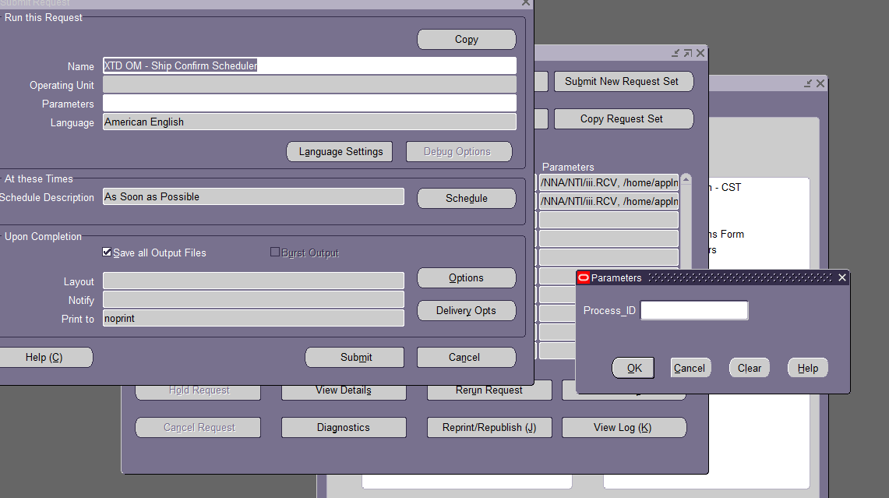
Kosongkan saja process id
Contoh hasilnya
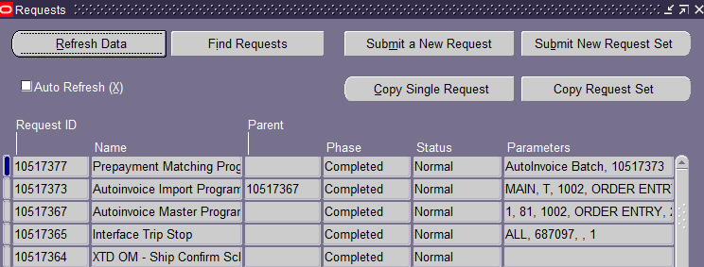

Contoh log yang terbentuk dari Autoinvoice Import Program
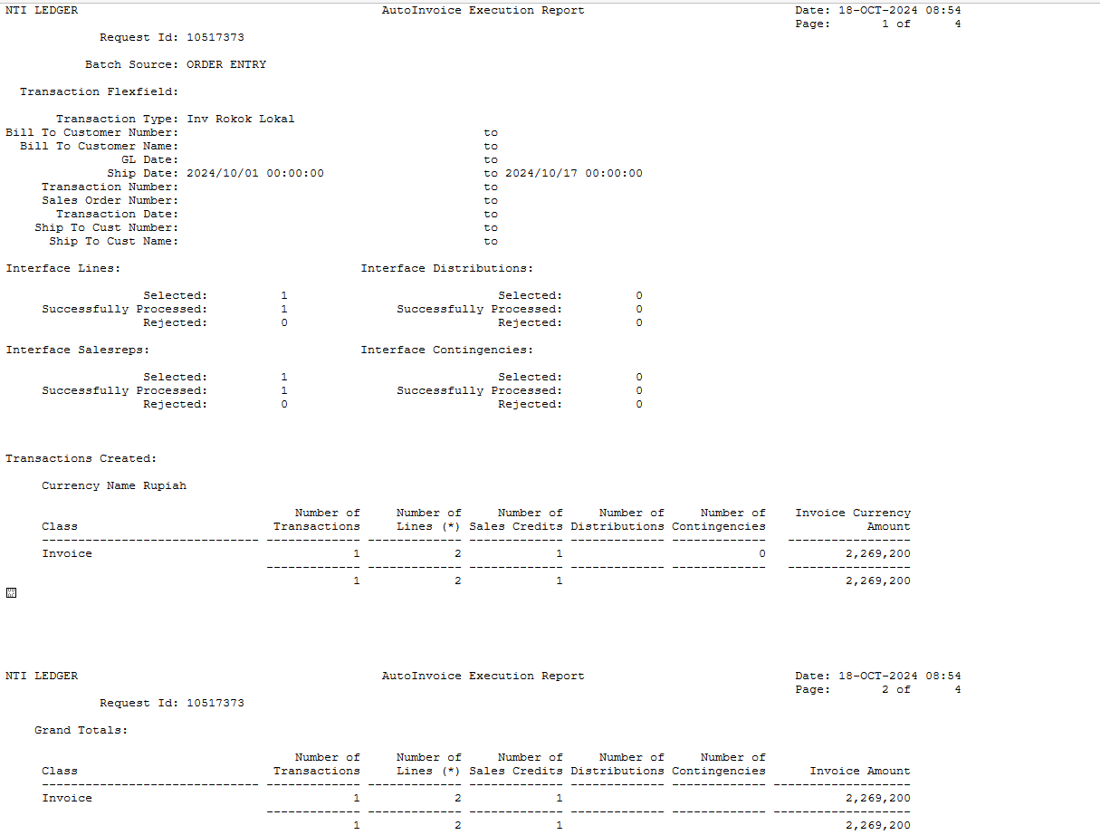

User menjalankan request berikut: XODI AR - Invoice Rokok
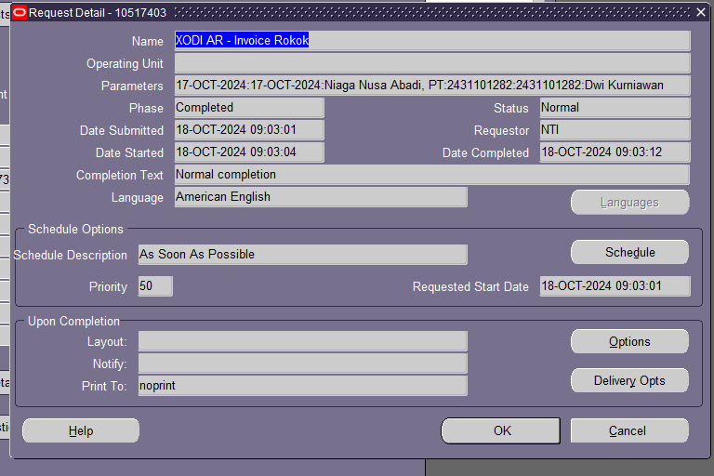

Contoh hasil:
